# SSDI 2020 Quiz questions

Quiz will be completed during the session.

1. Breslow’s depth report as 1.26 mm. How would this be recorded in the SSDI field.
   1. 1.2
   2. 1.3
   3. 2.0
   4. A1.3

*Breslow’s depth is only collected to the tenth of a millimeter (one digit to the left of the decimal). If a measurement is given to the hundredth (two digits to the left of the decimal), round up or down.*

1. ER percent positive stated as less than 55%. How is this coded in the SSDI field
   1. 055
   2. 054
   3. 549
   4. XX9

*Per the Record Lab Values when “less than” or “greater than” are used: Record the lab value as one less than stated when a value is reported as “less than X.”*

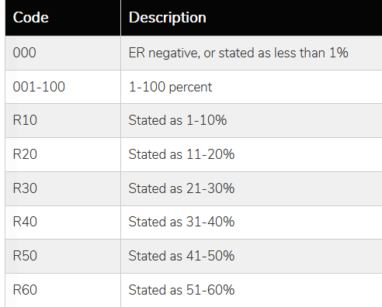



1. What is the time frame for recording lab values?
   1. Test must be done no earlier than 3 months before diagnosis
   2. Tests must be done prior to cancer directed treatment (unless instructed otherwise)
   3. Test must be after diagnosis
   4. A and B

*All lab values must be done no earlier than approximately three months before diagnosis AND  
Unless instructions for a specific laboratory test state otherwise, record only tests results obtained before any cancer-directed treatment is given (neoadjuvant therapy or surgical), AND*

*if multiple lab tests are available, record the highest value*

1. Patient diagnosed with breast cancer. ER and PR positive, but no information on percentage positive. Neoadjuvant therapy done. Post neoadjuvant surgery states ER positive, 95%, PR positive 62%. How are ER and PR percent positive coded?
   1. ER 095, PR 062
   2. ER R99, PR R70
   3. ER XX7, PR XX7
   4. ER XX9, PR XX9

*See Note 7 for ER and PR summary: If neoadjuvant therapy is given, record the assay from tumor specimens prior to neoadjuvant therapy. If neoadjuvant therapy is given and there are no results from pre-treatment specimens, report the findings from post-treatment specimens.*

1. Patient presents with a mass on the left side of her neck. A biopsy reveals the mass is an enlarged cervical lymph node with metastatic squamous cell carcinoma. A thorough exam failed to identify the primary tumor. However, the physician stated the metastasis was most likely from a head and neck primary. The metastatic lymph nodes was negative HPV per a p16 test.
   1. C11.9
   2. C10.9
   3. C76.0
   4. C14.8

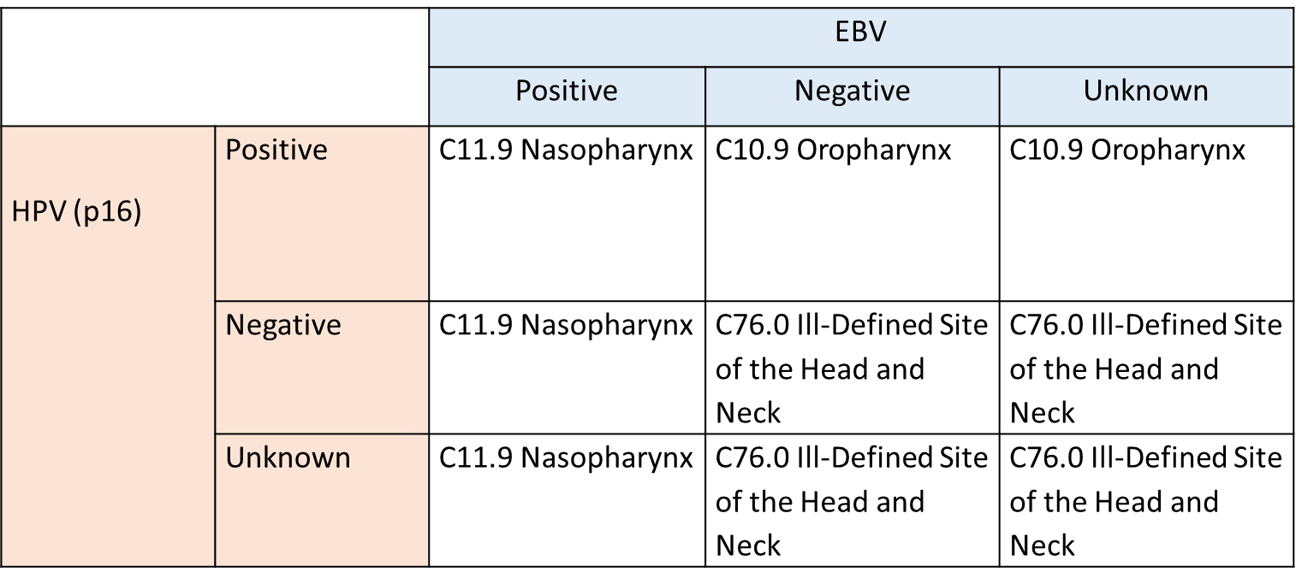

1. In the example above, what code would be assigned to schema discriminator 1?
   * 0 Not Occult
   * 1 Occult, Negative cervical nodes (regional head and neck nodes)
   * 2 Not tested for EBV or p16 in head and neck regional nodes (EBV and p16 both unknown)
   * 3 Unknown EBV, p16 negative in head and neck regional nodes
   * 4 Unknown p16, EBV negative in head and neck regional nodes
   * 5 Negative for both EBV and p16 in head and neck regional nodes
   * Blank Not C760, discriminator does not apply
2. The SSDI WG has representative from which of the following organizations?
   1. College of American Pathologist (CAP)
   2. AJCC
   3. SEER
   4. NPCR
   5. NAACCR
   6. Central Registries
   7. Canada
   8. All of the above
3. A CT shows a tumor confined to the lower half of the left kidney. The patient is not a surgical candidate. No treatment given. What do we assign to Ipsilateral Adrenal Gland Involvement?
   1. 0 Ipsilateral adrenal gland involvement not present/not identified
   2. 1 Adrenal gland involvement by direct involvement (contiguous involvement)
   3. 4 Ipsilateral adrenal gland involvement, unknown if direct involvement or separate nodule
   4. 9 ipsilateral adrenal gland not resected
4. Patient has a 1cm mass in her left breast. A core biopsy was done and pathology showed ductal carcinoma, Nottingham grade 2. The patient returns lumpectomy. Pathology shows an area of high grade ductal carcinoma in situ. No invasive tumor is identified. What is assigned to Grade Pathological?
   1. 1
   2. 2
   3. H
   4. 9
5. Patient has a biopsy of a small mass in her breast. Pathology shows high grade DCIS. The patient returns for lumpectomy. Pathology shows an area of invasive ductal carcinoma. What is Grade Pathological?
   1. 1
   2. 2
   3. H
   4. 9

