# Quiz 1

1. Which layer is NOT part of the esophageal wall?
   1. Submucosa
   2. Adventitia
   3. Serosa
   4. Muscularis
2. The mucosal layer of the esophagus includes?
   1. Suface epithelium
   2. Lamina Propria
   3. Muscularis Mucosa
   4. All of the above
3. Which type of gastric cancer spreads to the muscles of the stomach wall and make it thicker and more rigid?
   1. Adenocarcinoma
   2. Linitis Plastica
   3. Carcinoid Tumor
   4. Gastrointestinal Stromal Tumor
4. What is a common distant metastasic site for both primary esophageal and gastric cancers?
   1. Pleura
   2. Peritoneal Surface
   3. Lungs
   4. Liver
5. A patient with a tumor in the mid esophagus has an esophagectomy. The pathology report indicated the proximal margin was uninvolved by invasive carcinoma. This statement would indicate that…
   1. No tumor was present at the end of the specimen that prior to resection had been closest to the mouth.
   2. No tumor was present at the end of the specimen that prior to resection had been closest to the mouth.
   3. No tumor was present in the tissue surrounding the outer wall of the resected specimen.
   4. The pathologist was making an approximation of tumor involvement in the margins.
6. What primary site would we assign to a tumor arising in the esophagogastric junction?
   1. C15.2 Abdominal esophagus
   2. C15.5 Lower esophagus
   3. C15.8 overlapping lesion of the esophagus
   4. C16.0 Cardia
7. A patient had and EGD with a biopsy on 6/6/17. Pathology from the biopsy was well-moderately differentiated adenocarcinoma. The patient went on to have an esophagectomy 6/12/17 and was found to have a well differentiate adenocarcinoma. What value would we assign to the data item Grade?
   1. 1-well differentiated
   2. 2-moderately differentiated
   3. 3-poorly differentiated
   4. 4-undifferentiated
8. If the patient in the scenario above had been diagnosed in 2018, what values would we assign to the data items below?
   1. Clinical Grade __ 2
   2. Pathological Grade __ 2
   3. Post-therapy Grade __ blank

# Quiz 2

## Case scenario 1

An endoscopy of the esophagus revealed a malignant appearing tumor beginning at 39cm’s and extending to 43cm’s from the incisors. The tumor involves the distal esophagus and cardia. The epicenter of the tumor appears to be at the EGJ. The tumor extends proximally 1cm and distally it extends into the proximal stomach. The tumor does not extend into the body of the stomach. An endoscopic ultrasound was performed and the tumor was found to invade through the wall of the esophagus into the surrounding adventitia. Enlarged lymph nodes were identified 8 of which measured more than 1cm. The largest was 1.8cm. Two of the lymph nodes were biopsied. Biopsy of the primary tumor confirmed poorly differentiated adenocarcinoma. Both lymph nodes were positive for adenocarcinoma. No additional treatment was recommended due to the patient’s age and poor health.

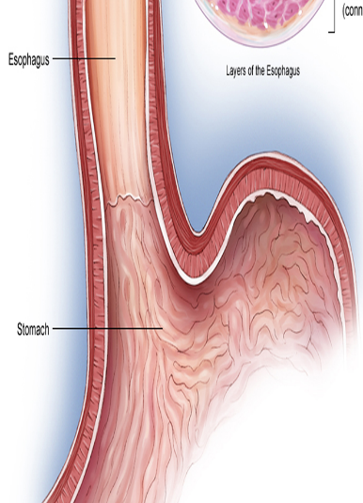

|  |  |  |
| --- | --- | --- |
| Data Item | 7th Edition | 8th Edition |
| Clinical T | cT3 | cT3 |
| Clinical N | cN3 | cN3 |
| Clinical M | cM0 | cM0 |
| Clinical Grade | 3 | 3 |
| Clinical Stage | 3C | 4A |
| Pathological T |  |  |
| Pathological N |  |  |
| Pathological M |  |  |
| Pathological Grade |  | 9 |
| Stage Group | 99 | 99 |

## Case Scenario 2

A patient presents for an abdominal CT scan and is found to have a large mass arising in the gastric fundus; no lymphadenopathy; no liver lesions. She then had an EGD with biopsy that showed a moderately differentiated adenocarcinoma in gastric fundus. The patient was treated with a partial gastrectomy. Pathology from the procedure showed a 2.1 cm moderately differentiated adenocarcinoma originating in the gastric fundus with tumor invasion into, but not through the submucosa. 16 lymph nodes were negative for metastasis.

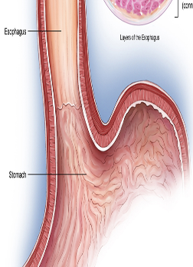

|  |  |  |
| --- | --- | --- |
| Data Item | 7th Edition | 8th Edition |
| Clinical T | cTX | cTX |
| Clinical N | cN0 | cN0 |
| Clinical M | cM0 | cM0 |
| Clinical Stage | 99 | 99 |
| Pathological T | pT1b | pT1b |
| Pathological N | pN0 | pN0 |
| Pathological M | cM0 | cM0 |
| Stage Group | 1A | 1A |

1. Which of the following procedures can be done as an endoscopic procedure?
   1. Ultrasound
   2. Mucosal resection
   3. Biopsy
   4. All of the above
2. An endoscopic mucosal resections would be given a surgery code as…
   1. 27-Excisional biopsy
   2. 30-Partial esophagectomy
   3. 40-Total esophagectomy, NOS
   4. 50-Esophagectomy, NOS with laryngectomy
3. Radiation therapy is more like to be given for what histology?
   1. Squamous cell carcinoma
   2. Adenocarcinoma
   3. Linitis plastica
   4. Signet ring cell carcinoma