Quiz 1

1. The line at which the esophagus meets the stomach is referred to as the…
   1. Fundus
   2. **Z-Line**
   3. Pylorus
   4. Rugae
2. If the epicenter of a tumor is in the esophageal gastric junction or in the proximal 5cm of the stomach and the cardia is involved which CS schema would be used?
   1. Esophagus schema
   2. **EsophagusGEJunction schema**
   3. Stomach schema
   4. None of the above
3. Match the letter with the anatomic site in the illustration below.
   1. Lesser curvature
   2. Fundus
   3. Distal esophagus
   4. 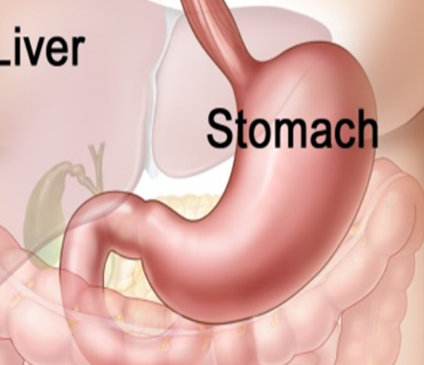pylorus

C

B

A

D

1. An adenocarcinoma of the esophagus is most like to occur in…
   1. **Distal esophagus**
   2. Proximal esophagus
   3. Upper third of the esophagus
   4. None of the above
2. Which of the following is not true concerning grade
   1. Grade is required to calculate AJCC stages 0-IIA for esophagus
   2. Grade is not required to calculate AJCC stages 0-III for stomach
   3. Grade for stomach and esophagus is based on the a four grade system
   4. **Grade is documented in CS SSF’s**

# Quiz 2

1. Final diagnosis is moderately differentiated adenosquamous carcinoma of the middle thoracic esophagus. The anatomic stage/prognostic grouping used is for adenocarcinoma.
   1. True
   2. **False**
2. Primary site is adenocarcinoma of the stomach fundus located 3 cm from the EGJ and extending into the EGJ. Primary is staged using AJCC 7th Ed. Chapter 10 Esophagus and Esophagogastric Junction.
   1. **True**
   2. False
3. Pathologic stage for esophagus depends on esophagectomy.
   1. True
   2. **False**
4. Metastatic tumor nodules in perigastric fat from primary stomach cancer is considered regional lymph node involvement.
   1. **True**
   2. False

EGD with biopsy: 2 cm lesion at 20 cm; moderately differentiated squamous cell carcinoma invading submucosa.

EUS: Upper thoracic lesion, 2 cm; adenopathy of single cervical node. No other abnormalities.

FNA biopsy of right cervical node: Squamous cell carcinoma.

Patient treated with chemoradiation.

1. What is the clinical AJCC stage?

T1b N1 M0 Grade 2 Any location Stage IIB

1. What is the pathologic AJCC stage?

T blank N blank M blank Stage blank

1. What is the Summary Stage 2000?
   1. 0 In situ
   2. 1 Localized only
   3. 2 Regional by direct extension only
   4. 3 Regional lymph node(s) involved only
   5. 4 Regional by BOTH direct extension AND regional lymph node(s) involved
   6. 5 Regional NOS
   7. **7 Distant**
   8. 9 Unknown

Abdominal CT scan: Large mass in gastric fundus; no lymphadenopathy; no liver lesions.

EGD with biopsy: Moderately differentiated adenocarcinoma in gastric fundus, more than 5 cm from EGJ.

Partial Gastrectomy: 5.1 cm moderately differentiated adenocarcinoma originating in the gastric fundus; tumor invades the muscularis propria; 0/16 metastatic lymph nodes.

1. What is the clinical AJCC stage?

TX N0 M0 Stage 99

1. What is the pathologic AJCC stage?

T2 N0 M blank Stage IB

1. What is the Summary Stage 2000?
   1. 0 In situ
   2. **1 Localized only**
   3. 2 Regional by direct extension only
   4. 3 Regional lymph node(s) involved only
   5. 4 Regional by BOTH direct extension AND regional lymph node(s) involved
   6. 5 Regional NOS
   7. 7 Distant
   8. 9 Unknown

# Quiz 3

1. Which of the following procedure can be done as an endoscopic procedure?
   1. Ultrasound
   2. Mucosal resection
   3. Biopsy
   4. **All of the above**
2. An endoscopic mucosal resections would be given a surgery code as…
   1. **27-Excisional biopsy**
   2. 30-Partial esophagectomy
   3. 40-Total esophagectomy, NOS
   4. 50-Esophagectomy, NOS with laryngectomy
3. Radiation therapy is more like to be given for what histology?
   1. **Squamous cell carcinoma**
   2. Adenocarcinoma
   3. Linitis plastica
   4. Signet ring cell carcinoma
4. A patient had a Billroth procedure. This would be given a surgery code of…
   1. 27-Excisional biopsy
   2. **30-gastrectomy, nos**
   3. 41 Partial gastrectomy
   4. 42-Total gastrectomy
5. An esophagogastrectomy entails...
   1. Removal of the entire esophagus
   2. Removal of the distal esophagus and pylorus of the stomach
   3. **Removal of the esophagus and fundus of the stomach**
   4. Removal of the GE junction only