# Quiz 1

1. For the purposes of coding:
2. The pancreas is broken down into head, neck, body, and tail
3. The pancreas is broken down into head, body, and tail
4. **The pancreas is broken down into head, body, tail, pancreatic duct, and islet of Langerhans**
5. Cancer in the Islets cells is denoted as an histologic code, not a topology code
6. The location of the pancreas makes surgery fairly straightforward, making most patients good surgical candidates
   1. True
   2. **False**
7. Some lymph nodes may be considered regional if a pancreatic tumor arises in the head of the pancreas, but distant if the tumor arises in the tail of the pancreas.
   1. **True**
   2. False
8. Because a person can live without a fully functioning pancreas, most pancreatic cancer patients ultimately die from liver failure.
   1. **True**
   2. False
9. Pancreatic cancer is:
10. The most common cancer among black men
11. Has decreasing incidence
12. **Is the 4th most common cause of cancer death in the US**
13. Is highly curable

# Quiz 2

You will need to your AJCC 8th edition manual or staging forms and the draft radiation codes to complete this quiz. The codes for Grade are below the worksheet. This patient was diagnosed in 2018.

## Scenario

A patient with a history of urothelial carcinoma of the bladder had an A/P CT and was found to have a 2.8 cm ovoid mass within the pancreatic tail is worrisome for a primary pancreatic neoplasm. There is no hydronephrosis. No enlarged upper abdominal lymph nodes. There is no abdominal ascites. The patient went on to have an endoscopic ultrasound that showed was a 21 x 25-mm round well-circumferenced lesion in the tail of the pancreas which was hypoechoic without cystic component. Four samples were taken for pathological and cytological diagnosis. No lymphadenopathy or additional mass was seen. Pathology from the FNA was positive for adenocarcinoma.

The patient went to have an open distal pancreatectomy, splenectomy, and omentectomy. Pathology from this procedure are below.

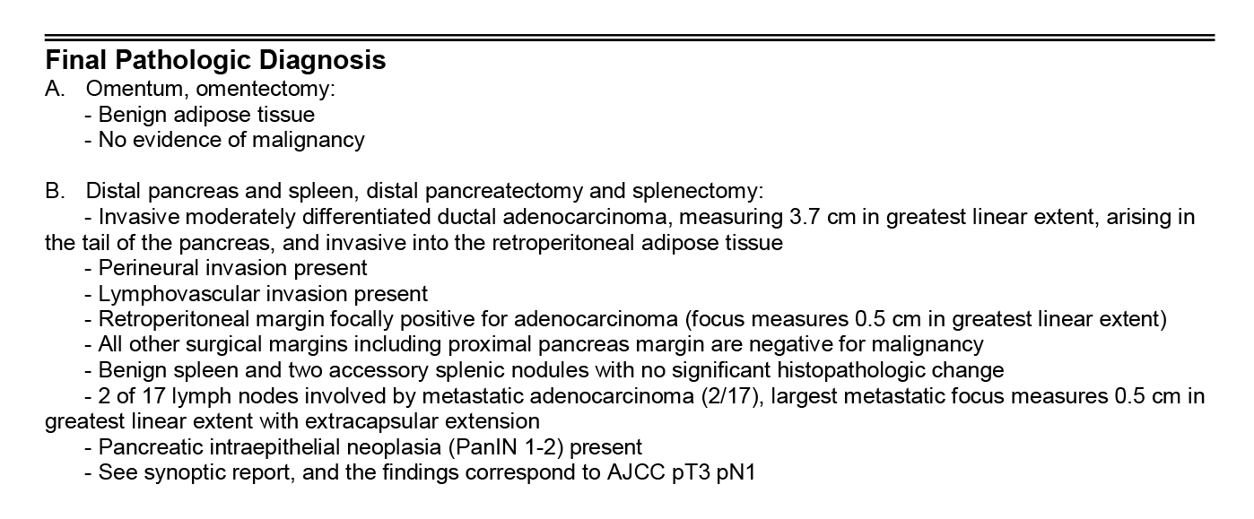

The patient had adjuvant chemotherapy and radiation.

**Radiation with concurrent Xeloda**

**TREATMENT DELIVERED:** A total dose of 5040 cGy was delivered in 28 fractions of 180 cGy directed to the patient’s tumor bed and regional lymphatics. Treatment was with a 10 MeV photon IMRT treatment plan. Treatment followed a CT simulation, which was used for treatment planning purposes. The patient’s treatment began of 5/10 and concluded 6/26 for a total of 47 days elapsed. Her treatment was delivered with concurrent Xeloda under medical oncology’s direction.

|  |  |  |  |  |  |  |  |  |  |  |  |  |
| --- | --- | --- | --- | --- | --- | --- | --- | --- | --- | --- | --- | --- |
| Grade | | | | | | | | | | | | |
| Clinical Grade | | 9 | | Pathological Grade | | | 2 | | Post-therapy Grade | | |  |
|  | | | | | | | | | | | | |
| AJCC Staging | | | | | | | | | | | | |
| Data Item | Value | | Data Item | | | Value | | Data Item | | | Value | |
| Clinical T | cT2 | | Pathologic T | | | pT2 | | Post-therapy T | | |  | |
| Clinical T Suffix |  | | Pathologic T Suffix | | |  | | Post-therapy T Suffix | | |  | |
| Clinical N | cN0 | | Pathologic N | | | pN1 | | Post-therapy N | | |  | |
| Clinical N Suffix |  | | Pathologic N Suffix | | |  | | Post-therapy N Suffix | | |  | |
| Clinical M | cM0 | | Pathologic M | | | cM0 | | Post-therapy M | | |  | |
| Clinical Stage | 1B | | Pathological Stage Group | | | 2B | | Post-therapy Stage Group | | |  | |
|  |  | |  | | |  | |  | | |  | |
| Radiation | | | | | | | | | | | | |
|  | | | | | **Phase 1** | | | **Phase 2** | | **Phase 3** | | |
| Radiation Primary Treatment Volume | | | | | 58 | | |  | |  | | |
| Radiation Treatment Modality | | | | | 02 | | |  | |  | | |
| Radiation to Draining Lymph Nodes | | | | | 05 | | |  | |  | | |
| External Beam Radiation Planning Technique | | | | | 05 | | |  | |  | | |
| Dose per Fraction | | | | | 00180 | | |  | |  | | |
| Number of Fractions | | | | | 028 | | |  | |  | | |
| Total Dose (per phase) | | | | | 005040 | | |  | |  | | |
| Number of Phases of Radiation Treatment to this Volume | | | | | 01 | | | | | | | |
| Radiation Treatment Discontinued Early | | | | | 01 | | | | | | | |
| Total Dose | | | | | 005040 | | | | | | | |
|  | | | | |  | | | | | | | |

|  |  |
| --- | --- |
| Grade Code | Description |
| 1 | G1: Well differentiated |
| 2 | G2: Moderately differentiated |
| 3 | G3: Poorly differentiated |
| 9 | Grade cannot be assessed (GX); Unknown |