# Instructions:

All cases are 2018 diagnosis year. If you do not have an AJCC 8th edition manual use the [staging forms](https://cancerstaging.org/references-tools/deskreferences/Pages/Cancer-Staging-Forms.aspx) (you will need the manual to assign stage to real cases, but for this exercise the staging forms may be used). Use [SEER RSA](https://staging.seer.cancer.gov/eod_public/list/1.0/) to code the grade fields and to assign summary stage 2018. A draft copy of the radiation coding instructions has been posted for the purposes of these case scenarios.

# Case Scenario 1

A 64 year old male presented with a history of pulmonary nodules being followed by CT. A CT of the chest shows a 3 cm pancreatic adenocarcinoma centered in the body of the pancreas. Associated atrophy of the pancreatic tail. Associated new narrowing of the splenic vein. No evidence of metastatic disease.

The patients CA 19-9 is 241 (normal range is <34).

The patient went on to have an open distal pancreatectomy and splenectomy. The mass within the distal body was completely resected and three lymph nodes removed.

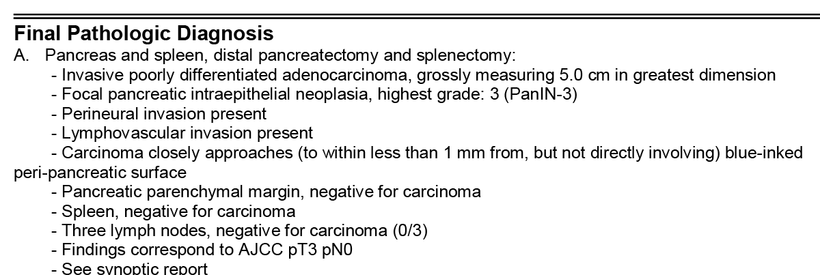

Following surgery the patient completed a full course of Xeloda and Gemcitabine.

|  |  |  |  |  |  |  |  |  |  |  |
| --- | --- | --- | --- | --- | --- | --- | --- | --- | --- | --- |
| **Case Scenario 1** | | | | | | | | | | |
| Primary Site | C25.1 | Histology | | | 8140 | Behavior | | | 3 | |
| Clinical Grade | 9 | Pathological Grade | | | 3 | Post-therapy Grade | | |  | |
| **Stage/ Prognostic Factors** | | | | | | | | | | |
| Clinical T | | cT2 | | Post-therapy T | | | |  | | |
| Clinical T Suffix | |  | | Post-therapy T Suffix | | | |  | | |
| Clinical N | | cN0 | | Post-therapy N | | | |  | | |
| Clinical N Suffix | |  | | Post-therapy N Suffix | | | |  | | |
| Clinical M | | cM0 | | Post-therapy M | | | |  | | |
| Clinical Stage | | 1B | | Post-therapy Stage | | | |  | | |
|  | |  | |  | | | |  | | |
| Pathological T | | pT3 | | Summary Stage 2018 | | | | 1 | | |
| Pathological T Suffix | |  | | Tumor Size Summary | | | | 050 | | |
| Pathological N | | pN0 | | Regional Nodes Positive | | | | 00 | | |
| Pathological N Suffix | |  | | Regional Nodes Examined | | | | 03 | | |
| Pathological M | | cM0 | |  | | | |  | | |
| Pathological Stage | | 2A | |  | | | |  | | |
| **Treatment** | | | | | | | | | | |
| Diagnostic Staging Procedure | | | 00 | **Systemic Therapy Codes** | | | | | |  |
| **Surgery Codes** | | |  | Chemotherapy | | | | | | 03 |
| Surgical Procedure of Primary Site | | | 30 | Hormone Therapy | | | | | | 00 |
| Scope of Regional Lymph Node Surgery | | | 4 | Immunotherapy | | | | | | 00 |
| Surgical Procedure/ Other Site | | | 2 | Hematologic Transplant/ Endocrine Procedure | | | | | | 00 |
|  | | |  | Systemic/Surgery Sequence | | | | | | 3 |
|  | | | Phase 1 | Phase 2 | | | Phase 3 | | |  |
| Rad Primary Treatment Volume | | | 00 |  | | |  | | |  |
| Rad Treatment Modality | | | 00 |  | | |  | | |  |
| Radiation to Draining Lymph Nodes | | | 00 |  | | |  | | |  |
| Ext Beam Rad Planning Technique | | | 00 |  | | |  | | |  |
| Dose per Fraction | | | 00000 |  | | |  | | |  |
| Number of Fractions | | | 000 |  | | |  | | |  |
| Total Dose | | | 000000 |  | | |  | | |  |
| # of Phases of Rad Tx to this Volume | | | 00 | | | | | | | |
| Rad Treatment Discontinued Early | | | 00 | | | | | | | |
| Total Dose | | | 000000 | | | | | | | |

# Case Scenario 2

An 82 year old male presents with an elevated liver function test. A CT of the abdomen and pelvis showed a 3 cm pancreatic adenocarcinoma involving the uncinated process, which abuts the superior mesenteric vein. The mass is causing secondary obstruction of the biliary tree and pancreatic duct. Three tiny side branch type IPMNs within the pancreas. There are enlarged low density lymph nodes seen in the suprapancreatic region along the proper hepatic artery consistent with metastasis.

An endoscopic ultrasound and FNA of the primary tumor was performed and confirmed adenocarcinoma.

**Radiation Oncology Consult**

IMPRESSION AND RECOMMENDATION: This is an 82-year-old male who has a locally advanced adenocarcinoma of the head of the pancreas surgically unresectable. We discussed role of radiation therapy with the patient. We recommend concomitant chemoradiation therapy. The patient has already seen a medical oncologist and will be starting of Gemzar chemotherapy along with radiation therapy. We recommend 5040 cGy in 28 treatments over 5-1/2 weeks to the known gross tumor area. I have discussed side effects and outcome thoroughly with the patient. The patient is in agreement. We will coordinate by initiating radiation therapy with chemotherapy with medical oncology.

**1/12 Patient started Gemzar**

**Radiation Summary:**

Patient received concomitant chemoradiation therapy to the pancreatic area. We started this course of radiation therapy on 01/10, completed on 02/16. He initially received 4500 cGy in 25 fractions over 34 elapsed calendar days followed by boost to the gross tumor volume area consisting of 540 cGy in 3 fractions. Thus, over a period of 36 elapsed calendar days, the final tumor dose was 5040 in 28 fractions. These were delivered via 3D conformal beam technique using 15 MeV photon beam. The patient tolerated this therapy fairly.

|  |  |
| --- | --- |
| Course: C1 | Course C1 |
| Treatment Site: PANCREAS | Treatment Site: PANCREAS BST |
| Energy: 15X | Energy: 15X |
| Dose/Fx (cGy): 180 | Dose/Fx (cGy): 180 |
| #Fx: 25 / 25 | #Fx: 3 / 3 |
| Dose Correction (cGy): 0 | Dose Correction (cGy): 0 |
| Total Dose (cGy): 4,500 | Total Dose (cGy): 540 |
| Start Date: 1/10 | Start Date: 2/14 |
| End Date: 2/13 | End Date: 2/16 |

|  |  |  |  |  |  |  |  |  |  |
| --- | --- | --- | --- | --- | --- | --- | --- | --- | --- |
| **Case Scenario 2** | | | | | | | | | |
| Primary Site | C25.0 | Histology | | | 8140 | Behavior | | | 3 |
| Clinical Grade | 9 | Pathological Grade | | | 9 | Post-therapy Grade | | |  |
| **Stage/ Prognostic Factors** | | | | | | | | | |
| Clinical T | | cT4 | | Post-therapy T | | | |  | |
| Clinical T Suffix | |  | | Post-therapy T Suffix | | | |  | |
| Clinical N | | cNX | | Post-therapy N | | | |  | |
| Clinical N Suffix | |  | | Post-therapy N Suffix | | | |  | |
| Clinical M | | cM0 | | Post-therapy M | | | |  | |
| Clinical Stage | | 3 | | Post-therapy Stage | | | |  | |
|  | |  | |  | | | |  | |
| Pathological T | |  | | Summary Stage 2018 | | | | 4 | |
| Pathological T Suffix | |  | | Tumor Size Summary | | | | 030 | |
| Pathological N | |  | | Regional Nodes Positive | | | | 98 | |
| Pathological N Suffix | |  | | Regional Nodes Examined | | | | 00 | |
| Pathological M | |  | |  | | | |  | |
| Pathological Stage | | 99 | |  | | | |  | |
| **Treatment** | | | | | | | | | |
| Diagnostic Staging Procedure | | | 00 | **Systemic Therapy Codes** | | | | |  |
| **Surgery Codes** | | |  | Chemotherapy | | | | | 02 |
| Surgical Procedure of Primary Site | | | 00 | Hormone Therapy | | | | | 00 |
| Scope of Regional Lymph Node Surgery | | | 00 | Immunotherapy | | | | | 00 |
| Surgical Procedure/ Other Site | | | 0 | Hematologic Transplant/ Endocrine Procedure | | | | | 00 |
|  | | |  | Systemic/Surgery Sequence | | | | | 0 |
|  | | | **Phase 1** | **Phase 2** | | | **Phase 3** | |  |
| Rad Primary Treatment Volume | | | 58 | 58 | | |  | |  |
| Rad Treatment Modality | | | 02 | 02 | | |  | |  |
| Radiation to Draining Lymph Nodes | | | 00 | 00 | | |  | |  |
| Ext Beam Rad Planning Technique | | | 04 | 04 | | |  | |  |
| Dose per Fraction | | | 00180 | 00180 | | |  | |  |
| Number of Fractions | | | 25 | 03 | | |  | |  |
| Total Dose | | | 004500 | 00540 | | |  | |  |
| # of Phases of Rad Tx to this Volume | | | 02 | | | | | | |
| Rad Treatment Discontinued Early | | | 01 | | | | | | |
| Total Dose | | | 005040 | | | | | | |