# Quiz 1

1. Summary Stage is used to track trends over time
   1. True
   2. False
2. Summary Stage 2018 can only be used for cases diagnosed 2018 and forward
   1. True
   2. False
3. Summary Stage 2018 does not use any schema discriminators
   1. True
   2. False
4. Summary Stage 2018 uses prognostic factors or biomarkers in determining stage
   1. True
   2. False
5. Code 5 (Regional, NOS) is no longer a valid code for Summary Stage
   1. True
   2. False
6. Summary Stage allows the use of ambiguous terminology
   1. True
   2. False
7. Code 8, Benign/Borderline, can be collected on any benign/borderline cases that a registry chooses to collect other than Brain/CNS/Intracranial Gland
   1. True
   2. False
8. New chapters have been added to align with AJCC 6th, 7th, and 8th editions
   1. True
   2. False
9. If AJCC defines involvement as regional (collected in either T or N), than SS2018 will also have it collected as regional (1-4)
   1. True
   2. False
10. Codes and coding instructions for Summary Stage 2018 can be found in all of the following sources except:
    1. SEER RSA
    2. SEER Summary Stage 2018 (.pdf manual)
    3. Registry software
    4. NAACCR SSDI website

Quiz 2

## Case 1-Colon

A patient presented for a screening colonoscopy and was found to have a pedunculated polyp in the descending colon. The polyp was excised.

The pathology report showed the polyp was a tubular adenoma with a focus of intraepithelial adenocarcinoma. No evidence of submucosal invasion. Margins were negative. No further treatment was done.

|  |  |  |  |  |  |
| --- | --- | --- | --- | --- | --- |
| Data Item | Value | Data Item | Value | Data Item | Value |
| Clinical T |  | Pathological T | pTis | Post-Therapy T |  |
| cT Suffix |  | pT Suffix |  | pT Suffix |  |
| Clinical N |  | Pathological N | cN0 | Post-Therapy N |  |
| cT Suffix |  | pN Suffix |  | pN Suffix |  |
| Clinical M |  | Pathological M | cN0 | Post-Therapy M |  |
| Clinical Stage | 99 | Stage | 0 | Post-Therapy Stage |  |
| Bonus-Summary Stage 2018 | | | **IS** | | |

## Case 2 Rectum

8**/22/18**

**History and Physical**

A 57 year-old white male presented today for abdominal perineal resection. He originally presented 5/6/18 for a colonoscopy with a biopsy and was found to have a 4.2cm fungating tumor located in his rectum. A biopsy confirmed poorly differentiated adenocarcinoma. An MRI with contrast showed tumor in the rectum perforating the rectal wall and extending into the perirectal tissue. 7-8 perirectal lymph nodes are indicative of metastasis. Liver, spleen, pancreas, kidneys and adrenal glands did not show any abnormalities. His CEA was found to be elevated at 19.4 ng/ml.

The patient completed a full course of neoadjuvant chemotherapy and radiation and presents today for a transabdominal resection. Current CEA is 2.3 ng/ml.

**8/22/18**

**Pathology –Abdominal perineal resection**

Tumor Site**:**  Rectum

Tumor Size: .5cm

Histologic Type: Adenocarcinoma

Histologic Grade: Low grade

Tumor Extension: Tumor involves the lamina propria, but does not extent into the submucosa.

Proximal and Distal Margins: Uninvolved by invasive carcinoma

Circumferential Margin: Uninvolved by invasive carcinoma.

Lymph-Vascular Invasion: Not identified

Perineural invasion: Not identified

Tumor Deposits: Not identified

Number of Lymph Nodes Involved: 0

Number of Lymph Nodes Examined: 36

**8/25/18 Discharge Summary**

The patient is recovering from his surgery and has been discharged home.

|  |  |  |  |  |  |
| --- | --- | --- | --- | --- | --- |
| Data Item | Value | Data Item | Value | Data Item | Value |
| Clinical T | cT3 | Pathological T |  | Post-Therapy T | pTis |
| cT Suffix |  | pT Suffix |  | pT Suffix |  |
| Clinical N | cN2b | Pathological N |  | Post-Therapy N | pN0 |
| cT Suffix |  | pN Suffix |  | pN Suffix |  |
| Clinical M | cM0 | Pathological M |  | Post-Therapy M | cM0 |
| Clinical Stage | 3C | Pathological Stage |  | Post-Therapy Stage | 0 |
| Bonus-Summary Stage 2018 | | | **4-Regional disease with lymph nodes**  **Clinical evaluation since pathology is less** | | |

## Case 3-Lung

3/11/18 History: A 66 year-old male with no history of tobacco use presented with a several-months’ history of cough and lower back pain, and an 11.3-kg weight loss. Because of the persistent cough and development of hemoptysis, further imaging studies were obtained.

3/15/18 IMPRESSION:

1. Multilobulated, peripheral pulmonary mass in the left lower lobe measuring 2.8 x 1.9 x 2.6 cm. This is suspicious for malignancy. Suggest further evaluation with PET-CT or biopsy. 2.
2. Additional 7 mm pulmonary nodule in the left upper lobe along the left major fissure.
3. Moderate dextroscoliosis of the thoracic spine with a Cobb angle measuring approximately 31 degrees.
4. Severe levoscoliosis of the lumbar spine, with a Cobb angle measuring approximately 43 degrees.
5. 5. Mild chronic height loss of the T7 vertebral body

3/17/18 PET/CT

FINDINGS: There is a hypermetabolic multilobulated nodule within the posterior left lower lobe which measures 2.5 x 1.5 cm in greatest transverse dimensions and has a maximum SUV of 7.2. The previously described 7 mm nodule within the left major fissure is not hypermetabolic. There are no hypermetabolic lymph nodes within the axilla, hila, or mediastinum. There are no other areas of hypermetabolism suspicious for malignancy.

IMPRESSION:

Hypermetabolic multilobulated left lower lobe nodule highly suspicious for malignancy. Recommend percutaneous sampling.

3/21/18

OPERATION: Bronchoscopy, left thoracoscopy, wedge resection left lower lobe followed by left lower lobectomy, mediastinal node sampling.

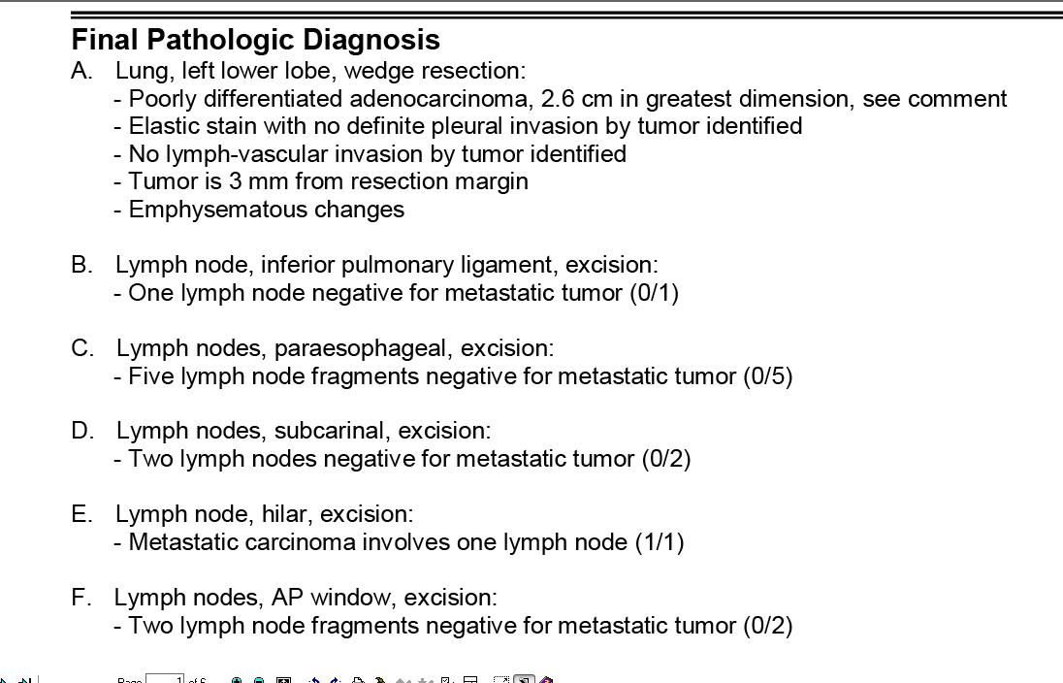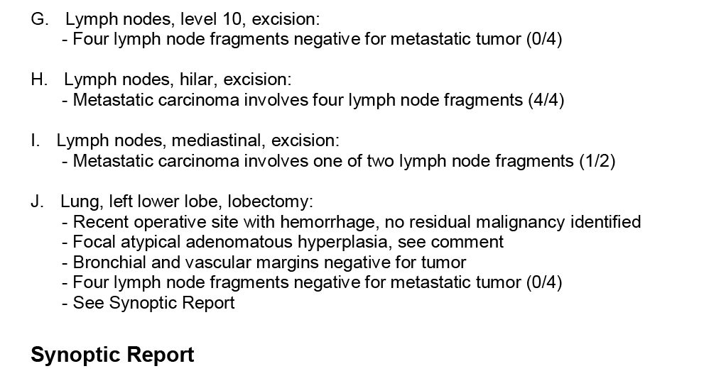

The patient had subsequent radiation and chemotherapy.

|  |  |  |  |  |  |
| --- | --- | --- | --- | --- | --- |
| Data Item | Value | Data Item | Value | Data Item | Value |
| Clinical T | cT1c | Pathological T | pT1c | Post-Therapy T |  |
| cT Suffix |  | pT Suffix |  | pT Suffix |  |
| Clinical N | cN0 | Pathological N | pN2 | Post-Therapy N |  |
| cN Suffix |  | pN Suffix |  | pN Suffix |  |
| Clinical M | cM0 | Pathological M | cM0 | Post-Therapy M |  |
| Clinical Stage | 1A3 | Pathological Stage | 3A | Post-Therapy Stage |  |
| Bonus-Summary Stage 2018 | | | **3-Localized tumor with positive lymph node** | | |